* In a drive in movie theatre (Or potentially in a normal movie theatre)

<https://www.google.com/search?q=drive+in+movie+theater&rlz=1C1GCEA_enUS812US812&source=lnms&tbm=isch&sa=X&ved=0ahUKEwjs77SX9aPdAhVSDq0KHZODDm4Q_AUICygC&biw=1249&bih=1287#imgrc=KtxZgdH6qXsK3M>:

* On a theatre or bigger stage

<https://www.google.com/search?q=curtained+theater+stage&hl=en&tbm=isch&source=iu&ictx=1&fir=NL-0CnVamzBv3M%253A%252CK0C70NlkaIggfM%252C_&usg=AFrqEzc8kC3ndyk3oCay4aVsnMGh-qAq2w&sa=X&ved=2ahUKEwjVo5vA9qPdAhUCYawKHTwxAusQ9QEwBHoECAUQDA#imgrc=NL-0CnVamzBv3M>:

* Classic Bar Fight Scenario

<https://www.google.com/search?q=long+bar&rlz=1C1GCEA_enUS812US812&source=lnms&tbm=isch&sa=X&ved=0ahUKEwitzIPN9qPdAhUF16wKHSiKA5IQ_AUIDCgD&biw=1249&bih=1287#imgrc=cgJltlifIX9vVM>:

<https://www.google.com/imgres?imgurl=https%3A%2F%2Fi0.wp.com%2Fwww.duchessofdisneyland.com%2Fwp-content%2Fuploads%2F2015%2F09%2Fmilelongbar1.jpg&imgrefurl=http%3A%2F%2Fduchessofdisneyland.com%2Fpark-history%2Fmile-long-bar%2F&docid=rQ3GEyA68Di6HM&tbnid=bPrpaZs3DJsTPM%3A&vet=10ahUKEwjls4TP9qPdAhVPhq0KHdDKAJ0QMwjkASgiMCI..i&w=1024&h=591&bih=1287&biw=1249&q=long%20bar&ved=0ahUKEwjls4TP9qPdAhVPhq0KHdDKAJ0QMwjkASgiMCI&iact=mrc&uact=8>

* Drive in car wash

<https://www.google.com/search?hl=en&ei=LdWPW4TeNIbAtQXGs5jwBQ&q=drive+in+car+washmachines&oq=drive+in+car+washmachines&gs_l=psy-ab.3..33i160j33i10.293206.294932..295162...0.0..0.96.507.8......0....1..gws-wiz.......0i71j0i13j0i13i30.BWL3yBQcR6s>

* Airfield/port
* Amusement Park
* Inside a Jet liner (Concord or fancier Boeing)
* Shopping mall
* Dance hall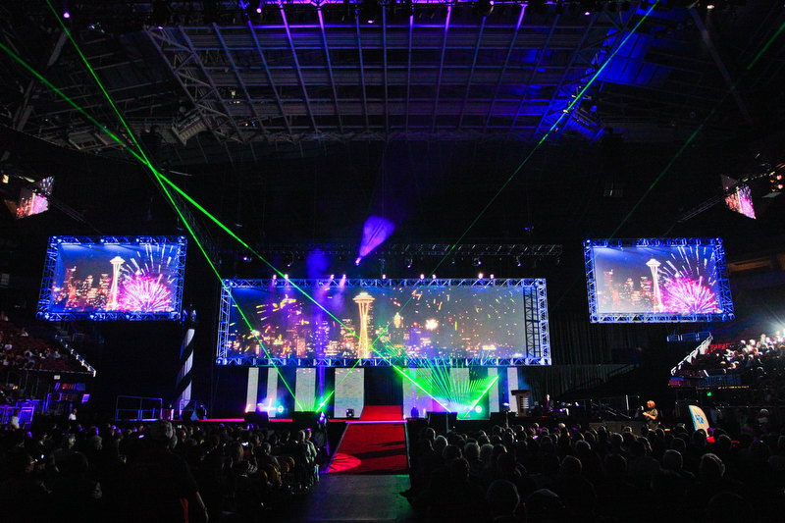
* CD/Record Store
* Old timey Barber Shoppe
* Some type of grand hall

<https://www.google.com/search?q=grand+hall&rlz=1C1GCEA_enUS812US812&source=lnms&tbm=isch&sa=X&ved=0ahUKEwinrbCNvKTdAhURXK0KHcGOCaAQ_AUICygC&biw=1249&bih=1287#imgrc=1khb2-Lx5eKLgM>:

ETC